**VM Decommission Process**

1. Once we received request for VM decommission from Server Owner. We can navigate to Azure portal and select the VM under Virtual Machine service and stop the VM.

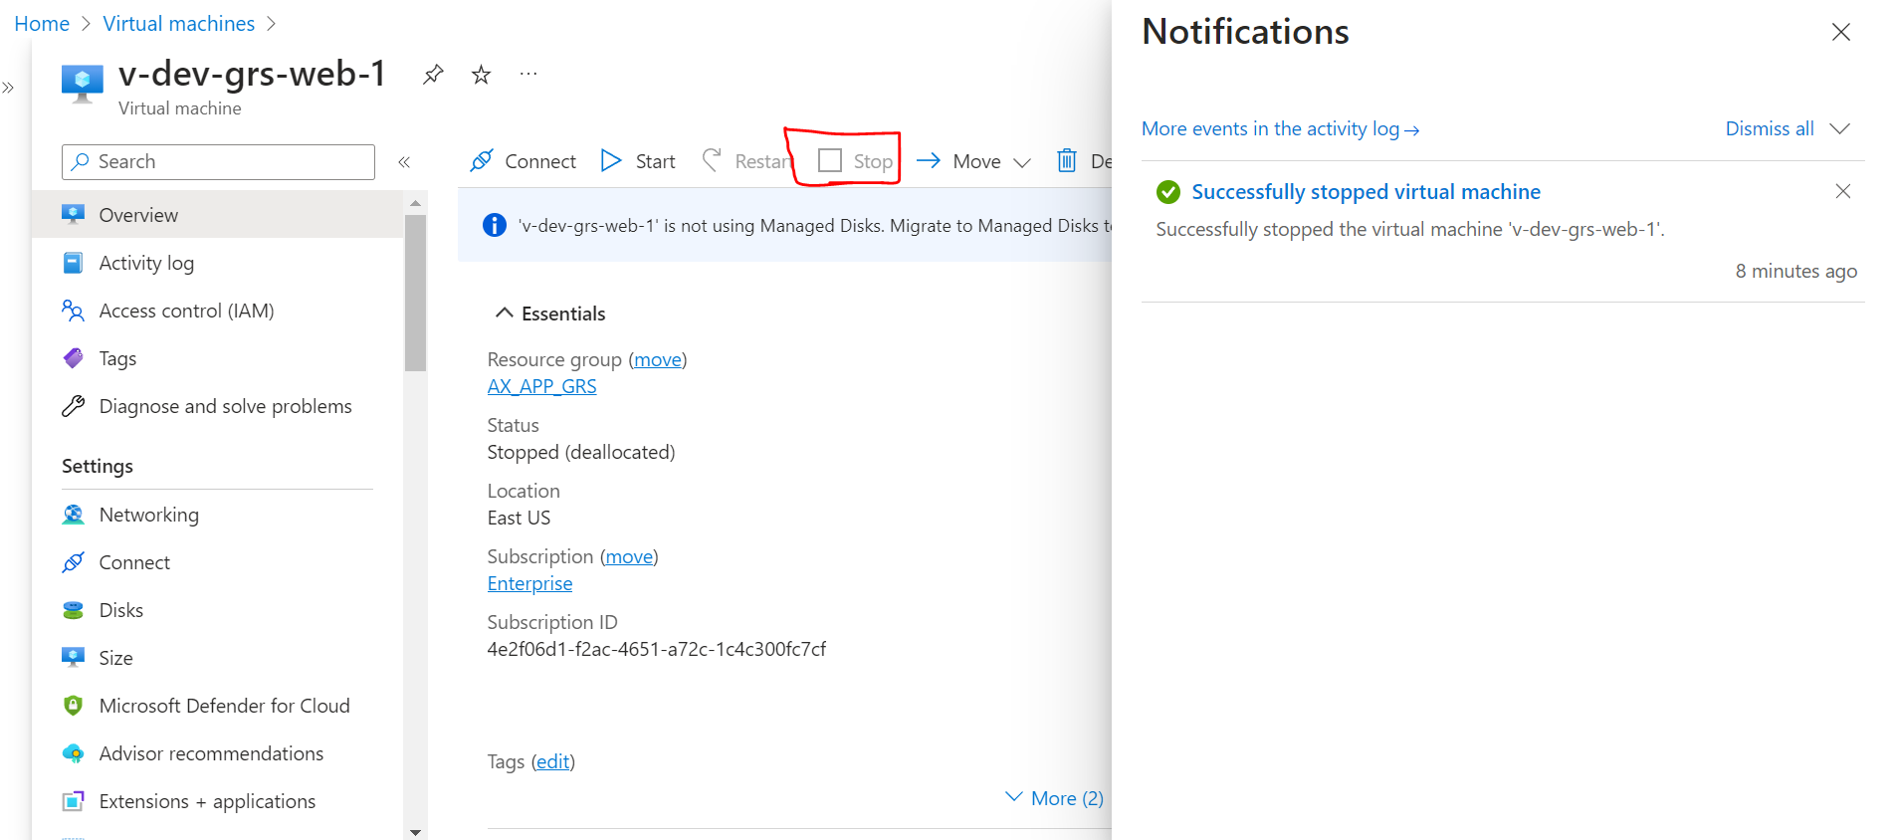

2. After stopped (deallocated) we can inform SCOM team to remove server from monitoring. And we can assign task to SCOM under RITM or Change.

3. Stop the backup, if backup is configured.

1. Click on Stop backup.

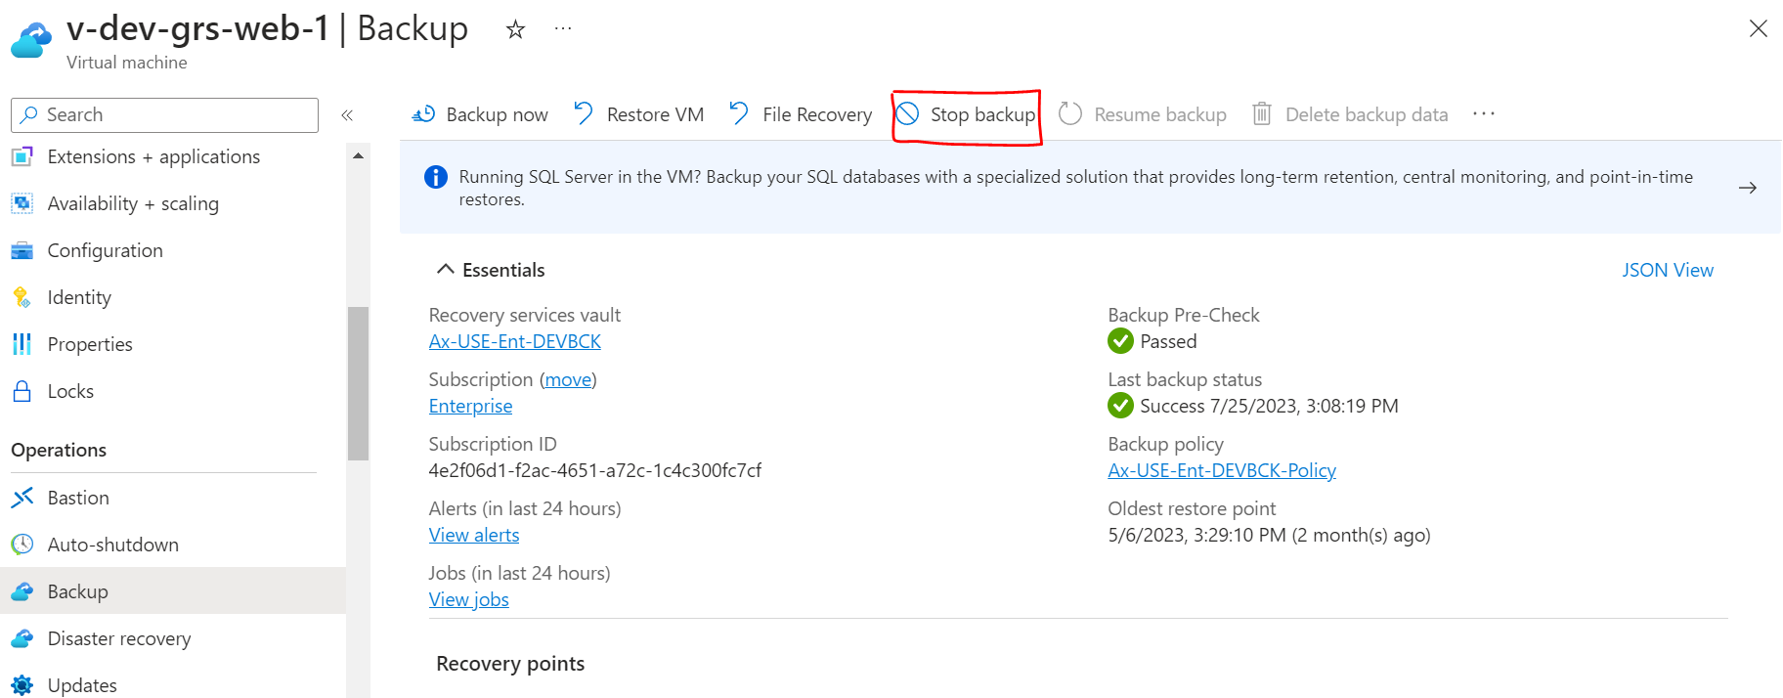

1. Provide the details like below and click on stop backup.

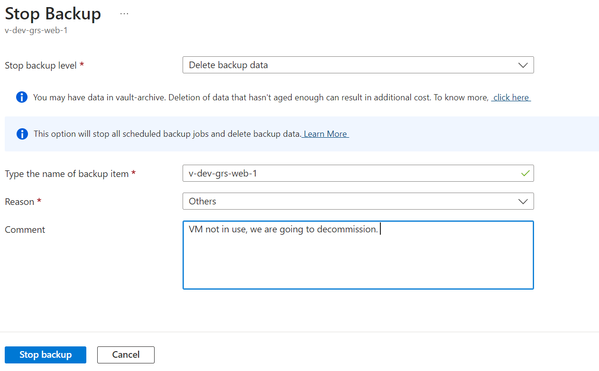

1. Backup has been deleted we can see the notification like below.

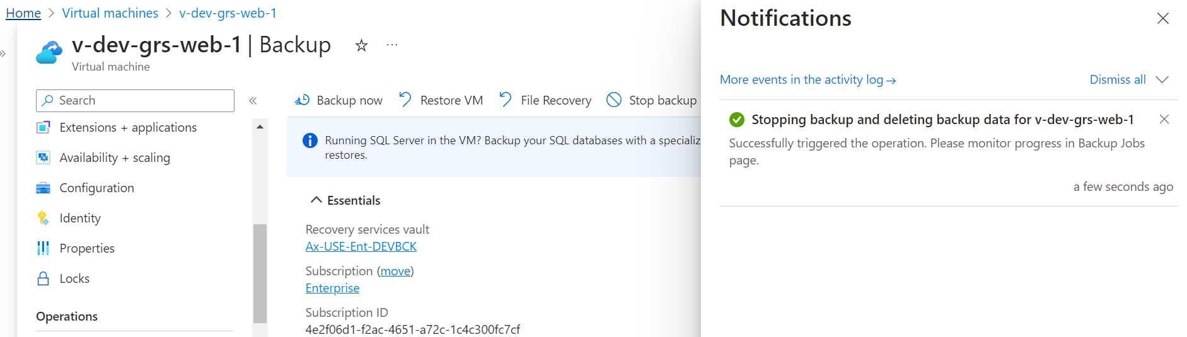

4. Disable the Replication, if replication enabled.

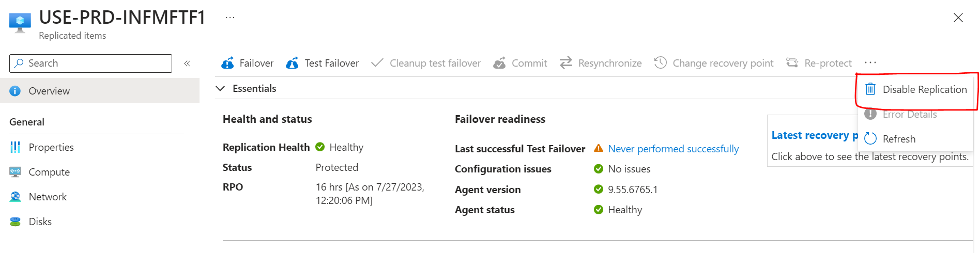

5. Once done all the above steps we can monitor the server for 5 days. If anyone reported on it.

6. If no one reach us for the server these 5 days. We can raise a normal change and delete it from Azure portal.

7. While deleting the VM make sure we can select the dependencies as well (OS Disk, Data Disk, Network Interfaces).

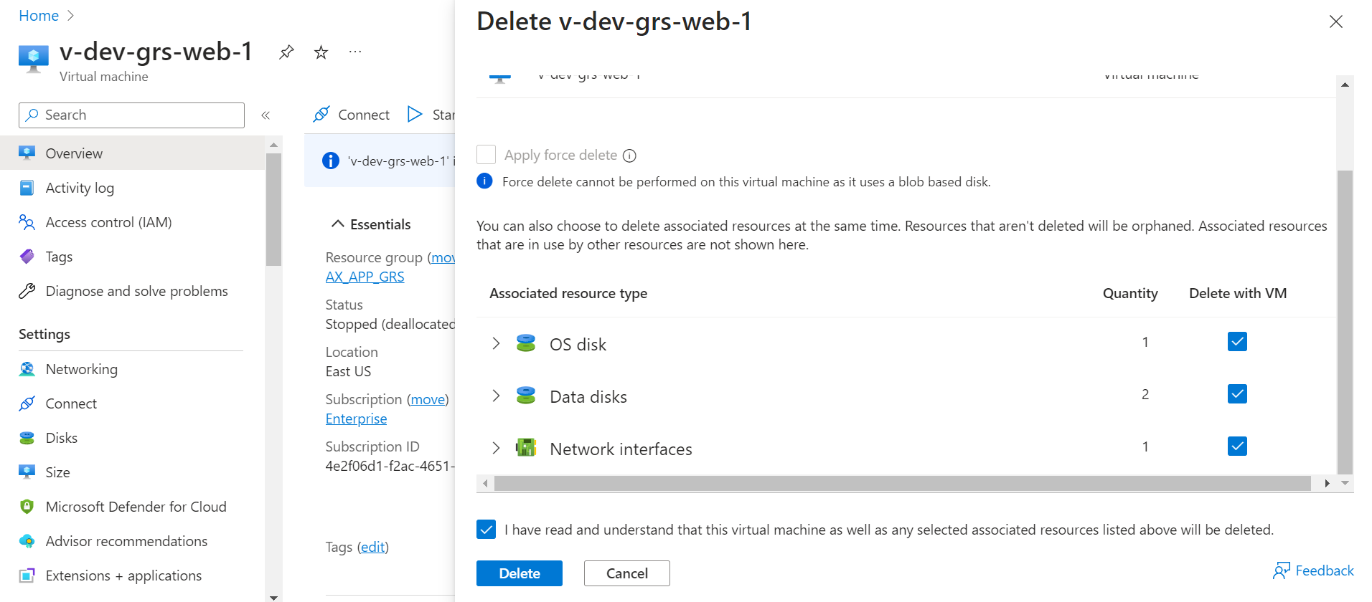

8. Once VM has been deleted successfully. We can assign tasks to below teams.

|  |  |
| --- | --- |
| **Assignment group** | **Short description** |
| WINTEL & Active Directory Admin | Please remove DNS entries and Objects |
| CSIRT | Please remove server in QRADAR |
| Configuration Management Team | Please remove server in CMDB |
| SCCM/ Intune Platform Support | Please remove server from SCCM |

9. Will close the RITM or Change. Once all the required team’s confirmation for their tasks.